1. Introduction and Motivation

Why Dallas?

Whether will people would like to pay the premium?

1. Setup
2. Data Manipulation and Visualization
3. Data Wrangling
4. TOD vs. Non-TOD: Four Variables

2.2 Median Rent Comparison

1. Grouped Bar Plot
2. Comparison Table
3. Graduated population

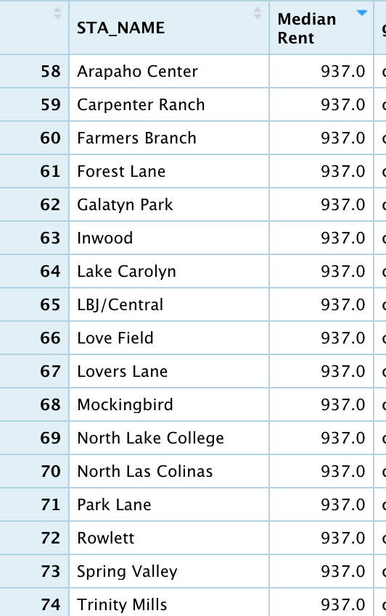

1. Rent as a function of distance to subway stations
2. Crime Rate and

# Intro

Transit-Oriented Development, or TOD for short, is at the heart of the City of Dallas' long-range land use plan, [*forward*Dallas!]( https://dallascityhall.com/departments/pnv/strategic-planning/Pages/forward-dallas.aspx). Dallas is home to 74 passenger rail stations in the system of [Dallas Area Rapid Transit (DART)](<https://en.wikipedia.org/wiki/Dallas_Area_Rapid_Transit>), and each presenting a unique opportunity to develop a new mixed-use neighborhood. DART is a transit agency serving the Dallas–Fort Worth metroplex of Texas. It operates buses, light rail, commuter rail, and high-occupancy vehicle lanes in Dallas and twelve of its suburbs. DART reported the [92,000]( https://web.archive.org/web/20200523094728/https://www.apta.com/wp-content/uploads/2019-Q4-Ridership-APTA.pdf) average weekday riders in 4th quarter of 2019. In terms of the commute situation of residents in Dallas, [3.8%](https://assets.dmagstatic.com/wp-content/uploads/2020/04/Presentation-1.pdf) of Dallas residents commute via public transit while [50,000](https://assets.dmagstatic.com/wp-content/uploads/2020/04/Presentation-1.pdf) Dallas residents commute over an hour each way to/from work.

When DART originally proposed the system back in the 1980s, the hope was that new rail stations would spur on new developments of dense housing and commercial real estate. And so far, a new [study]( <https://www.dart.org/about/economicimpact.asp>) has just shown how productive and important DART is to the overall North Texas economy, generating billions of dollars in revenue, taxes and jobs.

Accordingly, this project is aimed at provide an overview on whether residents would like to pay more for the sake of the potential benefits from TOD in Dallas.

# Conclusion

Only 9 percent of the city’s total land mass is within a half-mile of a light rail station,

Part of the problem is that the city hasn’t acted to create the conditions for development around the approximately 2,700 acres of vacant land near transit. (<https://www.dmagazine.com/frontburner/2020/04/dallas-finally-seeks-to-take-active-role-in-transit-oriented-development/>)

**Increasing rates are all larger in TOD tracts.**

Jeff

<file:///Users/penguin/Downloads/Homework1-JeffStern.html>

Although non-TOD areas take the lead in median rents, household income and population density compared to TOD areas, the increasing rates of those indicators are comparatively higher, indicating a trend that Dallas residents are willing to live alongside TOD areas and get access to transit system and potential benefits. Even if burglary crime is comparatively prevalent across TOD areas, residents’ enthusiasm is still there. Hence, to some extent, it is safe to conclude that residents in Dallas would like to pay more for TOD.

Despite a plausible plan, the construction of TOD areas still needs to take up some challenges and address existing problems. For instance, it is necessary that City of Dallas should control the rapid increase of rent compared to the increase of household income, otherwise, despite being willing to live in TOD areas, residents cannot afford the crazy rent.

For the further study, city planners and policy makers should leverage zoning ordinances to help to incentivize TOD in areas that are considered strong candidates, and also take residents household sizes and types into consideration.

for this type of development. T

alongside With the transit network being more and more accessible by residents, urban development and economic development would be witnessed. However, as the median rent keep rising, TOD areas will eventually be gentrified and result in the displacement of long-term residents, and that should be avoided. With the analysis above, several recommendations could be made:

* Extend the light trail lines and let more residents get access to public transit.
* Set financial incentives to attract mix-income housing and jobs to TOD areas.
* Address on safety issues and guarantee a safe living environment.

To maintain and enhance the positive effect of TOD, more demographic and social factors aside the ones adopted in this report need to be considered. Policy objectives need to be revised and updated constantly along with the development of the city.